GLEBE FARM DEVELOPMENT – OBJECTIONS

INTRODUCTION

My name is Peter Chase and I have lived at 45 Roman Road, Steyning, BN44 3FN since 1983 and I object to the proposed Planning Application DC/21/2233 for the building of 265 house at Glebe Farm for the following reasons – additional information is provided in the following paragraphs of this document;

1. Why has this Planning Application not been discarded as it does not reflect the Governments current thinking on the over development of the already overheated South East and is based on the outdated “housing algorithm”.
2. Why has the Application not taken into consideration the risk of the nearby lithium Battery Energy Storage System (BESS). Quoting the British company AIG *“The rapid rise of Battery Energy Storage Systems (BESS’s) that utilize Lithium-ion (Li-ion) battery technology brings with it massive potential – but also a significant range of risks. At AIG, we believe this is one of the most important emerging risks today”*
3. The proposed SUDS system relies on discharging into one of the two precious chalk streams (it’s not a ditch) running through Steyning and consequently polluting the Black Sewer (Stream) which is important for trout and sea trout spawning and is monitored under the Governments Water Frame Work Directive to ensure it meets good ecological status.
4. The proposed Substantial Urban Drainage System (SUDS ) will not be sufficient to cope with the rainfall and will worsen the flooding that regularly occurs in Kings Barn Lane following heavy rainfall.
5. It conflicts with the wishes of the Steyning community which clearly stated in the review that any new housing development should be evenly spread around the town to maintain the town’s balance and not be concentrated in one area.
6. This development must meet the “water neutral” stipulations announced by HDC.

ADDITIONAL INFORMATION

Paragraph numbers relate to the above numbered objections.

1. In order to stop the over development of the already overheated South East the application for in access of two hundred houses at Glebe Farm, Steyning should be rejected.

Lithium batteries pose a significant risk as a fault in one cell can cause a thermal runaway situation and lead to a significant explosion and the release of large amounts of Hydrogen Fluoride. This is a lethal gas and can linger and contaminate the local area. Concerns raised by Faversham residents are reproduced here for your convenience;

**https://favershamsociety.org/dangers-associated-with-lithium-ion-battery-energy-storage-systems/**

**Dangers Associated with Lithium-ion Battery Energy Storage Systems**

This was submitted to the examiners today.

I am fully aware that all deadlines for submission have passed, but the submission below is based on an important recent official document relevant to the several references to the 2012 battery fire in Flagstaff Arizona, that have been made throughout the CHSP Examination. The relevant regulator - Arizona Corporation Commission has recently (2/8/19) published its determination in that matter and in the matter of a more recent  2019 BESS fire and explosion in Surprise, Arizona. Given it's authoritative, definitive and conclusive nature, I am requesting that for completeness this submission is brought to the attention of the Examiners before they make their recommendation to the Secretary of State.

**1.Introduction**Throughout the course of the CHSP Examination, the Faversham Society and others have raised serious concerns about the safety of Li-ion Battery Energy Storage Systems (BESS) as evidenced by the incidence of runaway fires and explosions at BESS around the world. All such incidents involved BESS considerably smaller than that proposed by the applicants for CHSP. In our previous submissions and discussions during the examination, one of the more serious BESS fires - the 2 MWh battery fire in Flagstaff Arizona in 2012 was referenced, but at that time no conclusions had been drawn by the US authorities.

**2 Summary of the Determination**  
Commissioner Sandra D Kennedy of the relevant Regulator -  the Arizona State Commission, has now reported on the incident.  
[Her full report is here](https://favershamsociety.org/wp-content/uploads/2019/11/Arizona-Fire-ACC-August-2019-Kennedy-Letter.pdf)  
Her conclusions are of great significance and include:

''The Flagstaff Fire Department report ''....references fires with ''10-15 ft flame lengths'' that grew into ''flame lengths of 50-75 ft'' with fire ''appearing to be fed by flammable liquids coming from the cabinets'' '.*This highly significant piece of evidence shows how a fire can spread from one container to another and flatly contradicts the CHSP applicant's assertion that 100 containers are no more of a fire hazard than a single container and that any fire will be contained within a single container.*The Fire Department Report also states concerns about ''a serious risk of large scale explosion'' and ''the cabinets involved are full of lithium (sic) batteries that are extremely volatile if they come into contact with water.''  
The Commissioner clearly states:  
''**Knowing now how easily a fire and/or explosion can evidently occur at these types of relatively small(2MW) lithium ion battery facilities, it appears that a similar fire event at a very large battery facility (250MW+) would have very severe and potentially catastrophic consequences, and that responders would have a very difficult time trying to handle such an incident.''***The BESS proposed for CHSP is even larger at****700MWh*.**The Commissioner recommends that any large scale BESS  should be ''built in isolation'' and says ''an explosion could potentially flatten buildings at some distance''. She also draws the analogy that ''a 2MW battery facility is equivalent to 1.72 tons of TNT'' *This makes the CHSP BESS equivalent to 602 tons of TNT.****This is 1/20th of the TNT equivalent of the Hiroshima atom bomb****. Moreover the CHSP BESS is within one mile of Graveney village and two miles of the town of Faversham.*The Commissioner  also reinforces our community's fears about batteries ''with chemistries that include compounds that can release Hydrogen Fluoride in the event of a fire and/or explosion and states clearly that ''**those types of lithium ion batteries are not prudent and create unacceptable risks**'' *Moreover, contrary to the claims of the applicants  the Commissioner reinforces Dr Erasin's evidence stating that* ''large amounts of hydrogen fluoride could be released and dispersed that would affect and harm the public at a substantial distance downwind'' *and adds that* ''There would be concerns about lingering hydrogen fluoride contamination in the affected areas.''  
The Commissioner is clear that: ''water should not be used to suppress a fire such as a battery facility...'' -*yet this was the method the applicants and their advisors favoured for CHSP.*  
The Commissioner also lays down stringent requirements for the protection of responders (fire and rescue services etc) to any incidents. None of these has been acknowledged by the proposers or by KFRS.  
Given the absence of National Planning Statements on BESS, it is important that the Examination is guided by authoritative sources with experience of BESS projects. We would urge that the attached ACC Determination is the most thorough and up-to-date such source currently available. **3. Conclusion  
This Determination by the Arizona State Commission clearly reinforces the view of the Faversham Society and others, expressed in evidence to the Examination, that the risks associated with Lithium-ion batteries are unacceptable at any scale and especially when close to habitation. It is clear that a  proposal for a Battery Energy Storage System close to Faversham, which will be over five times the size of the current largest in the world, poses unparalleled risks and must be regarded as recklessly dangerous and totally unacceptable.**Professor Sir David Melville CBE, BSc, PhD, FInstP, CPhys, Hon DSc, Sen Memb IEEE(USA)  
Vice-ChairThe Faversham Society

3.

The “ditch” to the North of the site is NOT a ditch. It is one of the two precious chalk streams running through Steyning;

The stream joins the Black Sewer stream a few hundred meters downstream and this is important because it doesn’t dry up in summer and therefore sustains the Black Sewer stream. The Black Sewer is an important spawning habitat for trout, sea trout and course fish and since 2010 a lot of work has been done by the Ouse and Adur Rivers Trust, funded by the Environmental Agency, to protect and improve this stream to meet the Water Frame Work Directive.

The proposed SUDS system relies on using this as a drain and this is not acceptable.

Chalk streams are a unique and scarce habitat and many have been lost due to over abstraction and dry-up during the summer months. Twenty years ago the Black Sewer would be a fast running stream during the summer, but is now reduced to a trickle.

The South of England has 70% of the Worlds remaining chalk streams and these need to be valued and protected. They provide a unique habitat for specific fish, invertebrates and snails, which is important to maintaining good biodiversity.

Sea Trout are an endangered species so we need to do all that we can to protect their spawning habitat.

The SUDS system will collect and concentrate all water runoff from gardens, pavements and road surfaces, which will undoubtable contain garden weed killers, insecticides and detergents from car washing, and anything else that might carelessly be tipped into soil/drains.

The elevation of the proposed development site is approximately fifty feet higher than the ground to the North and contaminated ground runoff will naturally drain down into the stream over time, it has no where else to go.

This risks a repeat of the January 2019 pollution incident, which killed 1,773 fish in the Honeybridge Stream in Ashington – see photo below of poisoned sea trout and trout.

Heart breaking after spending years improving the stream. 1,100 Bullheads were killed and these provide a food source for birds such as Kingfishers and Herons etc.

This stream will take many years to recover.

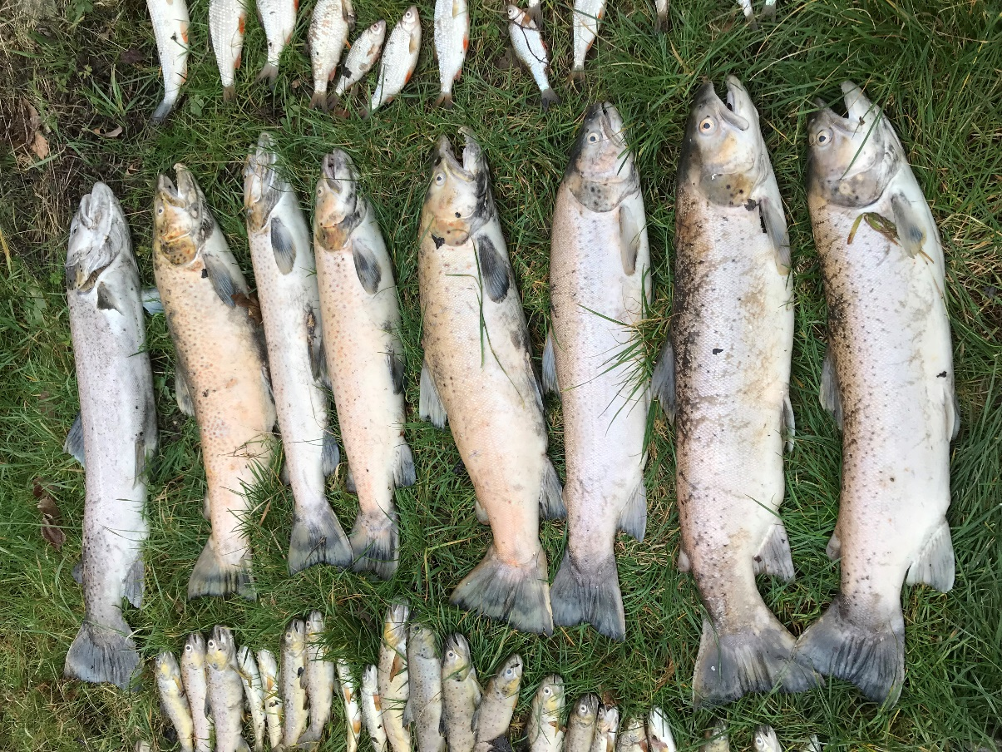

4.

The proposed site is a water logged field as identified in the Permeability Testing Survey quoted here;

“*It was initially proposed to completed soakaway testing within trial pit excavations at the site. However, due to the very wet and soft nature of the ground surface across the site at the time of these fieldworks, it was considered that significant difficulties would be experienced with trafficking heavy plant across the site.”*

*“The results of the falling head permeability tests undertaken at the remaining borehole installations recorded positive infiltration rates of between 3.12x10-10m/s and 2.95x10-8m/s at WS104 and WS110, respectively. Based on the results of the falling head permeability tests and the cohesive nature of the underlying ground conditions, it is considered that the use of shallow soakaways or other infiltration drainage systems is unlikely to be feasible for the site. Yours sincerely for ASL”.*

The Environmental Desk Top Study similarly reported that;

*“The ground surface in this area is locally hummocky with desiccation type cracks present indicating that this area may be seasonally waterlogged.*

*The former refuse tip is considered to be a potential source of hazardous ground gas that may migrate onto the subject site.*

*More significant potential sources of hazardous ground gas have been identified in the surrounding area including the former landfill located directly to the north-west and alluvial materials that may be present to the ASL Report No. 288-20-087-11R1 Report No. Page 17 of 23 September 2021 north. The potential risk to human health in the north is therefore considered to be high.*

*The majority of the eastern and central portions of the site are indicated to have the potential for groundwater flooding of property situated below ASL Report No. 288-20-087-11R1 Report No. Page 8 of 23 September 2021 ground level to occur. The south-west, north-east and central northern portions of the site are indicated to have the potential for groundwater flooding to occur at the surface.*

*The nearest surface water feature is an unnamed stream located on the north-western boundary. It is understood that this stream flows north into the Black Sewer located approximately 110m to the north. The unnamed stream is not classified chemically or biologically by the EA in the vicinity of the site. Black Sewer is classified by the EA as a category B –good water course in the vicinity of the site.*

*However, areas at risk from extreme flooding are located directly to the north and north-east.*

*There are two Substantiated Pollution Incident Register listings located within 0.5km of the site. The first listing relates to the release of crude sewage on 7th November 2012 located approximately 250m to the east. The EA has classified this incident as a category 2 – significant incident to water and land and a category 4 – no impact incident to air. The second listing relates to the release of crude sewage on 13th February 2013. The EA has classified this incident as a category 2 – significant incident to land, a category 3 – minor incident to water and a category 4 – no impact incident to air*

*The railway land in the west is classified in the Department for Environment, Food and Rural Affairs and the Environment Agency’s document CLR8 and the Department of the Environment Industry Profiles as a potential source of contamination in the form of metals, asbestos, polycyclic aromatic hydrocarbons, and polychlorinated biphenyl. This former land-sue is also considered to be a potential source of wind-blown metal and polycyclic aromatic hydrocarbon contamination.*

*There is the potential for Made Ground to be present in the east of the site associated with the infilled stream, associated with the worked ground in the north-west of Area 5, associated with the embankment in the west and associated with the small structures present at the site. Should Made Ground be identified, a general suite of determinants should be considered including asbestos. Any Made Ground is also considered to be a potential source of hazardous ground gas.*

*Finally, there is the potential for asbestos to be present within the building fabric of the residential dwelling located centrally in the south.*

*The critical receptors are considered to be the unnamed stream located on the northwestern boundary and the Principal Aquifer (controlled waters) and a female child (human health) for a residential development.”*

Relevant elevation points as measured by GPS are as follows;

* The stream/ditch to the North of the site – TQ 18190 11583 – 30 feet
* Black Sewer just upstream of Kings Barn Lane culvert- TQ 18627 11892 – 20 feet
* Adur/Black Sewer tidal flap – TQ19051 11537 – 9 feet

This shows that there is a very small drop in elevation from the Black Sewer culvert to the tidal flap where it discharges into the River Adur. This flap closes when the river level rises due to the incoming tide or due to heavy rainfall. Due to the massive amount of housing and industrial development up stream at Burgess Hill, the Adur has to cope with far more rainfall runoff than it has ever had to, to the point that it can’t really cope – witness all the flooding at Henfield. The river level therefore remains high for many days following heavy rain.

This results in the tidal flap closing and preventing flow from the Black Sewer and the water quickly backs up causing the road to flood at the Kings Barn Lane culvert – see photo below following one night of heavy rain on 21st October this year;

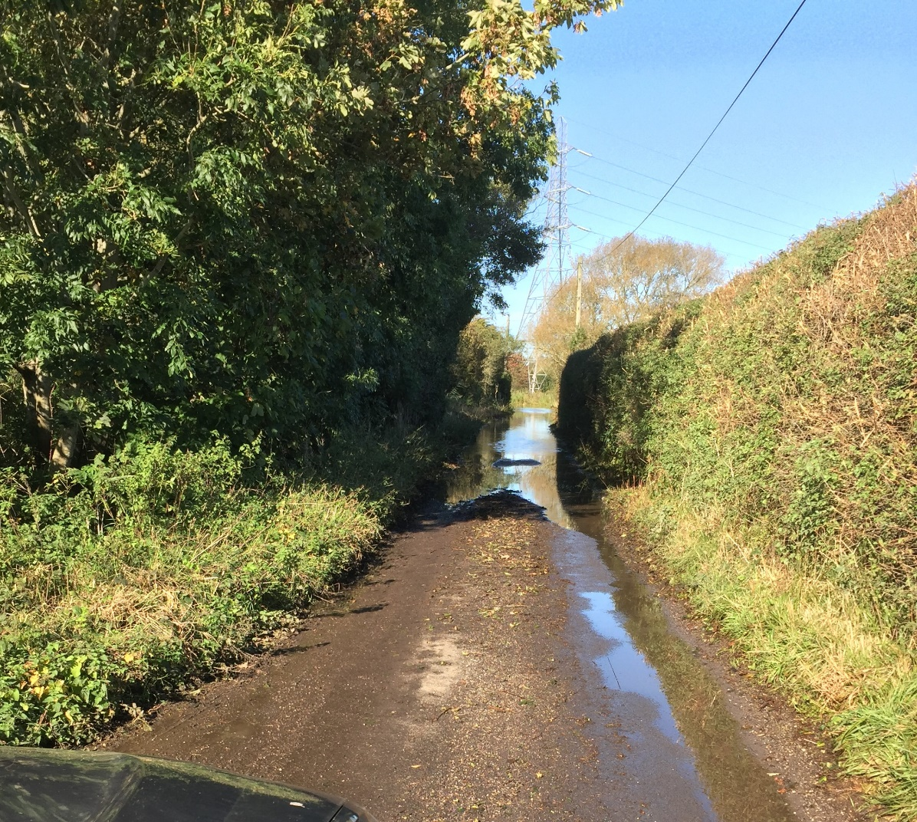

This lane regularly floods every year preventing residents from taking children to school, attending doctor appointments, getting to work and shops. Waist deep water has been reported in recent years, but nothing has been done to alleviate this.

The surveys conclude that the ground is not very permeable and therefore very little water will soak away.

A couple of ponds is unlikely to cope with the heavy rainfalls we currently experience and will quickly fill on the first day’s rain and the following days rain will flood out of the ponds and cause downstream flooding.

Climate change will make this far worse.

The proposed development and the associated SUDS system will exasperate this situation and is not acceptable.

There is a very big risk that during the building process the chalk stream and Black Sewer habitat will be destroyed forever.

The preparation of the site and the building process will involve breaking up and moving a lot of soil with the risk of massive amounts of soil runoff getting into the stream, smothering gravels and destroying the chalk stream and the Black Sewer.

There is a steep natural gradient from the proposed site running down to the stream to the North and it will not be possible to prevent runoff into the stream depositing large amounts of soil and sediment.

This will destroy the unique habitat and cannot be allowed to happen.